Peper, E., Harvey, R., & Takebayashi, N. (2009). Biofeedback an evidence based approach in clinical practice. Japanese Journal of Biofeedback Research, 36(1), 3-10.

Biofeedback an evidence based approach in clinical practice

Erik Peper², Richard Harvey² and Naoki Takabayashi³

² San Francisco State University, San Francisco, California U.S.A.

³ Institute for Holistic and Integrative Medicine, Kobe, Japan

Abstract
Clinical biofeedback procedures are highly effective ameliorating a variety of symptoms that range from urinary incontinence to hypertension as well as assess a person’s somatic awareness by making the invisible visible. The paper reviews the biofeedback process and some psychosomatic applications. Psychosomatic patients often demand more skills than just attaching them to the equipment. Successful treatment includes a) assessing physiology as a diagnostic strategy, b) explaining the illness processes and healing strategies that are congruent with patients’ perspective, c) reframing the patients’ illness beliefs, and d) psychophysiological training with homework practices to generalize the skills. This process is illustrated through the description of a single session with a patient who experienced severe gastrointestinal distress and insomnia.

Keywords:
Biofeedback
Gastrointestinal disorder
Insomnia
Clinical procedure
Education

Biofeedback is a subset of applied psychophysiology that can be used as a single procedure or a group of procedures embedded within other clinical treatments (Friman, 2008; Nestoriuc et al., 2008; Penberthy et al., 2005). Biofeedback procedures have been used for effectively treating a wide variety of illnesses ranging from attention deficit and hyperactivity disorders (ADHD) (Huang-Storms et al., 2007) to urinary incontinence (Glazer & Laine 2006). Although most biofeedback procedures are highly effective in both raising patient awareness and ameliorating symptoms, some biofeedback procedures are still considered exploratory. For example, the large research team of Fernández, Harmony, Fernández-Bouzas, Díaz-Comas, Prado-Alcalá, Valdés-Sosa, Otero, Bosch, Galán, Santiago-Rodríguez, Aubert, & García-Martínez (2007) explored the efficacy of EEG neurofeedback on improving cognitive performance in learning disabled children, finding that neurofeedback was more effective than placebo treatment in improving cognitive performance over 2 months post treatment. Whereas more follow-up is necessary for demonstrating long-term treatment efficacy for the Fernandez et al., (2007) neurofeedback procedure, the results look promising. A larger point is that solving complex treatment issues sometimes requires exploratory procedures. Furthermore, biofeedback strategies depend upon the severity of the illness symptoms as well as the skills of the biofeedback therapist. This paper presents a basic overview of biofeedback along with a case example illustrating an integrated biofeedback approach.

Biofeedback Process
Biofeedback has been described as a ‘psychophysiological mirror’, allowing patients to monitor and learn from physiological signals produced by the body (Peper et al., 2009). Biofeedback procedures utilize electronic sensors that are almost entirely noninvasive for monitoring physiological signals. One of the few exceptions includes specialized muscle training procedures in ‘single muscle unit training’ (SMUT) studies of athletes or, stroke patients that utilize fine needle electrodes for signal monitoring (Chalmers, 2008; Farina et al., 2005). Regardless of the type of sensor used, the physiological signals are filtered and processed, quantified, and displayed back (feedback), usually in visual or auditory forms; in addition, some other types of tactile/vibrotactile feedback can also be utilized. For example, vibrotactile feedback has been used to assist in training of balance in patients with vestibular dysfunction (Dozza et al., 2007). An example from popular culture would include Nintendo’s Wii Fit® device that monitors body position and balance. Regardless of the type of sensors used for physiological monitoring, all biofeedback procedures must include a training component that supports developing self-awareness and control over a person’s own physiology. As self-awareness increases, the person may achieve insight and control over how he or she moves, thinks, emotes, and reacts. At the same time the coach, teacher, experimenter, educator, or clinician may use the signal information to facilitate a particular educational or healing goal (Peper et al., 2009).

In both clinical and educational settings, biofeedback procedures and protocols commonly utilize computerized equipment for providing both immediate, real-time feedback (e.g. presented in the form of graphs, numbers, images, and sounds) as well as summary information of the feedback session. The information can serve to reinforce and shape behavior and increase awareness for achieving self-regulation goals. The basic schematic represented in Figure 1 illustrates some specific components of a typical biofeedback system. Note that the term ‘response markers’ indicates a dynamic process of learning, where the clinician/patient or trainer/trainee each have an opportunity for identifying critical moments of activity that may be reviewed as indicators of learning events. For example, if patients are learning to increase muscle control, either they or their therapist may identify a moment of increased awareness of muscle tension or muscle control (e.g. pelvic floor muscle for treating urinary incontinence). Whereas computerized biofeedback equipment allows for monitoring specific body functions (e.g. muscle tension), most modern equipment also allows for simultaneously monitoring of many body signals with polygraphic display. For example, having a polygraphic display would be useful to inform a patient not only that they are tensing their pelvic floor muscles, but also that they are holding their breath while doing so. Most computer based equipment can simultaneously display various combinations of biological signals such as muscles, body temperature, sweat response, heart rate, respiration and brain activity. The specific combinations of physiological systems that are monitored depend on the biofeedback procedure or protocol.
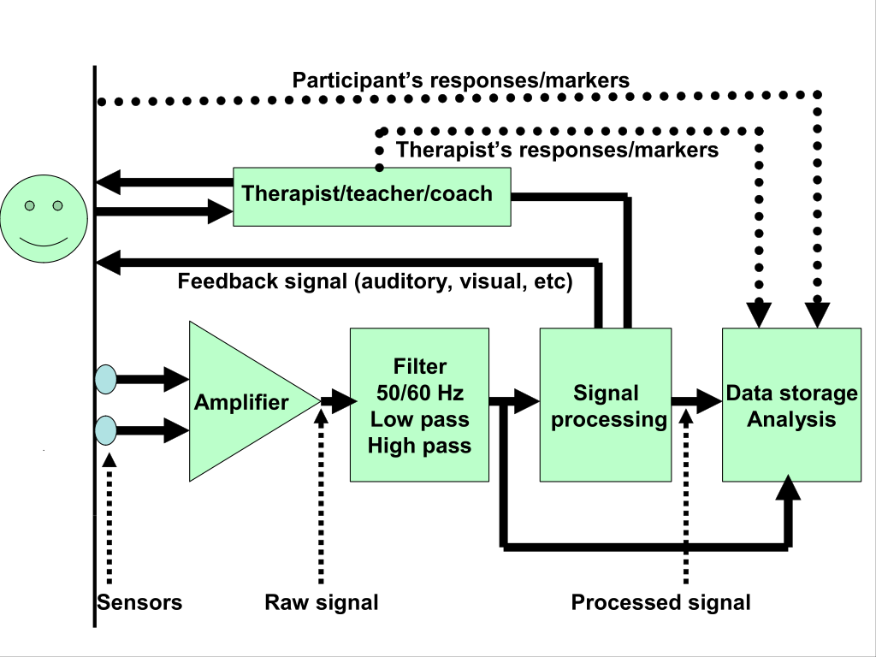
Figure 1. Flow diagram of biofeedback equipment in which the signal is recorded from the person, amplified, processed, stored for later retrieval and analysis, and transformed into a signal that is fed back to the participant. In many cases, the therapist/coach/trainer can be the intermediary for the feedback signal. In addition, the participant’s responses can be collected, analyzed, and correlated to the recorded physiological signals. By permission from Peper et al., (2009).

Monitoring oneself and then utilizing the information to practice and achieve self-regulation are the main goals of biofeedback. Some of the most effective self-regulation and biofeedback applications that are evidence based include the treatment of headache, hypertension, stress-related disorders, attention deficit disorders, epilepsy, abdominal pain, asthma and, urinary incontinence, etc. (Yucha & Montgomery, 2008).

Efficacy of biofeedback protocols vary by the number of sessions which typically range between 1 to 50 sessions. For example, patients who have learned to disuse their sphincter muscles (‘learned disuse’) and who are diagnosed with incontinence may reverse their disuse and regain sphincter control in 3 to 6 sessions with 80% decrease in incontinence episodes (Burgio, Whitehead, Engel, 1985; Burgio et al, 1998). Many biofeedback protocols require more training sessions to demonstrate efficacy especially if a totally new skill needs to be learned or a dysfunctional pattern needs to be inhibited or extinguished. Illnesses that are augmented or caused by stress or destructive life habit patterns usually take multiple training sessions because the person must first develop the awareness, second master the skill, and third integrate and generalize the biofeedback modulated skills into their daily lives. For example, biofeedback protocols for treating essential hypertension usually take 20 or more sessions since it includes learning how to control (increase) peripheral (hand and foot) warming, SEMG guided relaxation, autogenic phrases, self monitoring of blood pressure, cognitive reframing and breathing (Fahrion et al., 1986; McGrady, 1994; Linden & Moseley, 2006). Finally, the neurofeedback treatment for Attention Deficit Hyperactivity Disorder (ADHD) as well as for epilepsy requires 20 to 50 sessions to achieve clinical success (Masterpasqua & Healey, 2003; Sterman, 2000; Thompson & Thompson, 2003).

Major Uses of Biofeedback
Biofeedback is used in many ways ranging from diagnosing clinical symptoms to exploring self-awareness, states of consciousness and personal growth. Most commonly, biofeedback is used for:
- Diagnosing, assessing, and documenting objective data for research purposes or for charting a trainees’ clinical progress.
- Demonstrating for the client the mind-body relationship (e.g. that every thought has a corresponding somatic reaction and vice versa).
- Changing beliefs so that clients can become more active participants in the self-healing process.
- Mastery training of psychophysiological self-control.
- Enhancing a therapists’ awareness of a client’s or patient’s experiences.

Making the Invisible Visible
Physiological monitoring can be used to highlight physiological patterns that the client is unaware of and document changes that occur as a result of training/treatment. The objective physiological data can be used to assess the efficacy of the interventions as well as provide the data necessary for evidence-based education. For example, Doyle, Thomas & Peper (2007) used physiological monitoring for assessing the efficacy of Autogenic Training (AT). During the AT protocol, the participants followed a simple set of instructions:
(1) Sit on a chair with hands on their lap allowing their body to collapse so that their spine curved like a letter C thus totally relaxing their back with their head hanging down.
(2) While in this position, gently recite autogenic phrases such as, “My right arm is heavy”, “my arms and legs are heavy and warm,” “my heart beat is calm and regular,” etc.
(3) Repeat the procedure three times.

After the session, one of these participants reported that she felt her neck was relaxed during AT and her hands warmed up. The physiological data confirmed that the hands warmed up during the second and third cycle of Autogenic training; however, the client did not completely relax the muscles of her neck as shown in figure 2.

Figure 2. Physiological recording of right and left cervical SEMG, electrodermal activity and skin temperature. During the AT coach position (CP1, CP2 & CP3), the sEMG increased even though the person reported being totally relaxed (Doyle, Thomas & Peper, 2007).

The physiological recording was used to document the efficacy of hand warming in response to the AT protocol. The recording of neck SEMG demonstrated that she did not allow her neck to relax completely. In this example, neither the client nor the therapist were aware of the slight SEMG tension until the biofeedback equipment made ‘the invisible become visible’ in the SEMG recordings. Specifically, the client was able to see that she slightly lifted her head as she placed herself in the collapsed position. With this physiological information, the client learned ways to allow her neck muscle tension drop during subsequent sessions which resulted in decreased neck SEMG activity as training progressed. Thus the biofeedback information helped the participant to learn subtle somatic awareness as well as elucidating the psychological process that caused the slight increase in neck SEMG activity. In conversation with the trainer, she discovered that the lifting of her head was an indicator of slight vigilance and control (“I need to keep on guard and know what is going on.”) that had kept her from totally allowing herself to be in a relaxed autogenic state.

Making the Unconscious Conscious and accepting the mind-body connection
Biofeedback is a very useful tool for practitioners in the field of health promotion and psychosomatic medicine because biofeedback information is perceived as credible and objective. Patients often see their doctor because they believe that their illness is centered in their body, even though healthcare providers are aware that a large number of stress related psychological factors often contribute to, as well as reinforce, the illness process (Astin et al., 2003). Many patients reject any psychological origins of illness because a) psychological factors are not congruent with their illness beliefs and, b) because the maintenance of their disorder is modulated by the patient’s ongoing emotional and behavioral patterns. Unfortunately, referring patients for psychotherapy is often unsuccessful (Astin, 2003). The physiological connection between the mind and the body, using biofeedback procedures allows the patient to observe and accept that their physical symptoms are more than a purely physical phenomenon. Thus, the patients begin to accept that their illness needs to be addressed not only by treating their body, but also by changing their behaviors, thoughts and emotions. For psychosomatic patients, biofeedback is a “Trojan Horse”—the patient accepts the somatic biofeedback monitoring and than is forced to accept that the illness is more than their bodies’ dysfunction (Wickramasekara, 1988). The display of physiological information provides patients with the evidence they need to connect unaware/unconscious cognitive and emotional factors that affect their symptoms. Learning to control physiology implies learning emotional and cognitive control. It is based upon the psychophysiological principal linking mind and body that was stated by Green et al., (1970):
"Every change in the physiological state is accompanied by an appropriate change in the mental emotional state, conscious or unconscious, and conversely, every change in the mental emotional state, conscious or unconscious, is accompanied by an appropriate change in the physiological state."

Clinical biofeedback session
The clinical uses of biofeedback include: a) assessing physiology as a diagnostic strategy, b) explaining the illness processes and healing strategies that are congruent with patients’ perspective, c) reframing the patients’ illness beliefs, and d) psychophysiological training with homework practices to generalize the skills. This complex process is illustrated during a biofeedback session with a 38 year old mother of two children (ages 8 and 10), who has severe insomnia, episodic abdominal pain and recently experienced gastrointestinal bleeding due to a polyp which she interpreted as a sign of cancer. Before her bleeding was resolved, she became extremely concerned that it could be cancer and had to take a leave of absence from work because of her insomnia and abdominal discomfort.

The initial biofeedback session included a psychosocial history assessment in which she confirmed that she was vigilant and on guard, reactive to other people’s negative emotions and always “trying to do her best”. In addition, her husband was much less willing to compromise, she usually agreed (appeased) to her husband’s demands for the sake of family harmony. (Clinical notes included the comment: “Does her gastrointestinal distress reflect the colloquial phrase ‘I cannot stomach what is going on?). After achieving rapport with the patient, a short psychophysiological stress assessment was performed which included recording abdominal and thoracic respiration patterns and left scalene-to-right trapezius SEMG to monitor neck and shoulder tension (Peper et al, 2009). While sitting comfortably, she was sequentially guided to first relax, then think of a personal stressor, and finally, relax again and let go of the stressor.

The physiological patterns shown in Figure 3 clearly demonstrated that she breathed predominantly in her upper chest with significant scalene-to-trapezius SEMG activity and almost no abdominal respiratory movement across all conditions. During the stressor condition, she held her breath and her neck and shoulder tension slightly increased slightly.

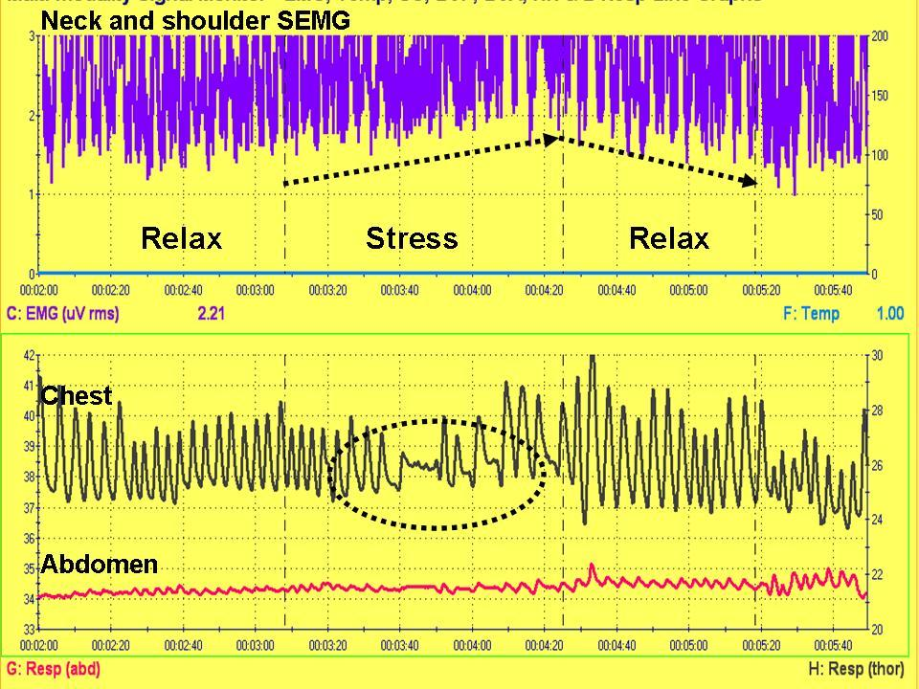

Figure 3. Physiological recording of a stressor assessment in which the scalene-to-trapezius SEMG (neck and shoulders tension) slightly increases and the breath pattern is significantly changed (a fear pattern associated with the stressor memory). The major breathing component is thoracic with significant scalene-to-trapezius muscle SEMG activity.

After the recording, the physiological patterns were shown and explained to the patient. The patient was told that chronic thoracic breathing implied that she was on guard and vigilant for danger. The limited abdominal movement reduced her lymph and blood flow through the abdomen as the blood flow was being shifted to the larger muscles needed for fight and flight response. Her body was in a chronic state of alarm and readiness which has lead to exhaustion. The slight increase in neck and shoulder muscle tension combined with the breath holding during the stress imagery suggested a fear response. If this pattern occurred often, it would mean that her neck and shoulder muscles could not relax/regenerate and thus she probably experienced neck and shoulder tension.

She confirmed that she experiences chronic neck and shoulders stiffness. In addition, the clinician suggested that her thoracic breathing pattern was probably learned in early childhood; namely, abdominal bracing and shallow breathing as a self-protective response against negative environmental and emotional stimuli such as anger from her parents. At the same time her hyper vigilance was conditioned through experiencing parental love and caring only if she performed a task quickly and well. As the relationships between psychophysiological and emotional patterns were explained, she recognized how these patterns related to her illness onset and maintenance. The patient’s shoulders relaxed, tears came to her eyes as she finally felt understood and realized that she was not the blame for her illness.

From this model gastrointestinal (GI) distress and insomnia were the cascading results of the fear/bracing patterns which consisted of shallow breathing as well as slight neck and shoulder tension. The physiological recordings also confirmed that she could learn to relax and let go of the negative stressful image, thus offering hope that she could learn skills to enhance her health. The applied psychophysiological and biofeedback assessment suggested a behavioral intervention –increased diaphragmatic breathing– by which she could reverse her illness patterns.

The next phase of the session consisted of teaching her slow diaphragmatic breathing using both the graphic displays of the abdominal and thoracic recording as well as thinking of positive memories and association of her children when they were babies. This memory association was chosen because earlier in the session she smiled and relaxed when she talked about her two children. Her task was to breathe in a similar pattern as babies–healthy relaxed babies breathe predominantly abdominally. In addition, she was also guided to exhale and imagine that the air would flow slowly down her arms and legs (Kajander & Peper, 1998; Peper, 1990). The short training session was enough to show that she could master a more functional pattern of breathing as shown by the physiological recording of the recording abdominal and thoracic respiration patterns in Figure 4.

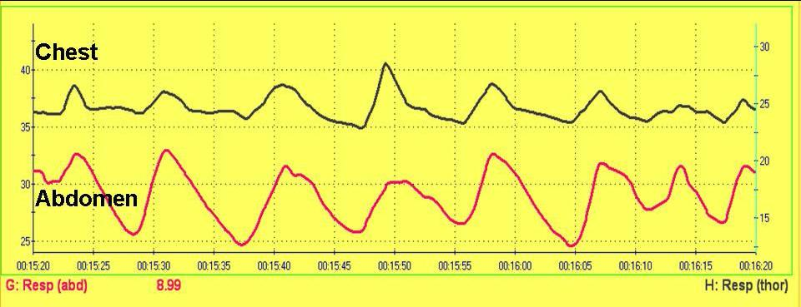

Figure 4. Physiological recording of respiration after of ten minutes of guided respiratory training.

After practicing for a few minutes she felt significantly more relaxed and at peace and her neck and shoulder tension had disappeared. Thus, she gladly agreed to practice slow diaphragmatic breathing for five or six breaths, 30 times during the day. She also agreed to practice this slow diaphragmatic breathing every time she caught herself rushing to perform a task such as serving her husband tea or jumping up to do something. She was to practice breathing slowly three or four times before performing ordinary tasks. Finally, she was assigned an additional homework practice of slow breathing at night in bed using a 2.5 kilogram bag of rice on her stomach to encourage slow breathing at night. Her task was to inhale by raising the weight on her abdomen and gently exhale by breathing down her arms and legs. If intrusive thoughts occurred, she was to refocus on breathing down her legs. Upon follow-up she reported that she faithfully practiced the homework and experienced significant symptom reduction and felt much better.

Conclusion
This case example, illustrated some of the components involved in clinical biofeedback used for making unconscious processes become more conscious. Biofeedback training and reinforcement is more than just attaching a patient or client to the equipment and performing an assessment or training. It includes the integration of assessment and training embedded within a holistic skill mastery protocol in which the patient becomes an active participant in the healing process.

Biofeedback training sessions offer patients several advantages over typical medical treatments that often end with a prescription of medications that remove the patient from the process of healing. The advantages include: a) providing a believable/congruent psychobiological model of the disease process coupled with an experience of positive change and hope; b) an opportunity for reinforcing the biofeedback information with actual physiological and cognitive skills that supports self-healing; and, c) an ongoing involvement with healing process through the practice of appropriate psychophysiologically derived homework. In summary, clinical biofeedback training is a type of skill training and not a passive drug treatment. The goal of biofeedback is learning to bring about effective change by allowing the individual to influence and reduce their symptoms. Biofeedback procedures are sometimes simple and easy to learn; however, developing skills of self-awareness and body control may take a lifetime to master.

References
Astin, J.A., Shapiro, S.L., Eisenberg, D.M. & Forys, K.L. (2003). Mind-body medicine: state of the science, implications for practice. Journal of the American Board of Family Practice, 16(2), March-April, 131-47.
Burgio,K.L, Locher, J.L, Goode, P.S., Hardin, J.M., McDowell,B.J, Dombrowski, M. & Candib, D. (1998). Behavioral vs Drug Treatment for Urge Urinary Incontinence in Older Women. A Randomized Controlled Trial. JAMA, 280(23), 1995-2000.

Burgio, K.L, Whitehead, W.E. & Engel, B.T. (1985). Urinary incontinence in the elderly. Bladder-sphincter biofeedback and toileting skills training. Ann Intern Med, 103(4), 507-15.
Dozza, M., Wall, C. 3rd., Peterka R.J., Chiari, L. & Horak, F.B. (2007). Effects of practicing tandem gait with and without vibrotactile biofeedback in subjects with unilateral vestibular loss. Journal of Vestibular Research, 17(4), 195-204.
Doyle, J., Thomas, C. & Peper, E. (2007).The mismatch between subjective relaxation and objective sEMG activity during Autogenic Training. Applied Psychophysiology and Biofeedback, 32 (1), 72.
Chalmers G.R. (2008). Can fast-twitch muscle fibers be selectively recruited during lengthening contractions? Review and applications to sport movements. Sports Biomechanics, 7(1), 137-57.
Fahrion, S.L., Norris, P.A., Green, A.M., Green, E.E., & Snarr, C. (1986). Biobehavioral treatment of essential hypertension: A group outcome study. Biofeedback and Self-Regulation, 11(4), 257-277.
Farina D, Gazzoni M & Camelia F. (2005). Conduction velocity of low-threshold motor units during ischemic contractions performed with surface EMG feedback. Journal of Applied Physiology, 98(4), 1487-94.
Fernández, T., Harmony, T., Fernández-Bouzas, A., Díaz-Comas, L., Prado-Alcalá, R.A., Valdés-Sosa, P., Otero, G., Bosch, J., Galán, L., Santiago-Rodríguez, Aubert, E., & García-Martínez, F. (2007). Changes in EEG current sources induced by neurofeedback in learning disabled children. An exploratory study. Applied Psychophysiology and Biofeedback, 32(3-4), 169-183.
Friman, P. C. (2008). Evidence-based therapies for enuresis and encopresis. In: Steele, R. G., Elkin, T. D. & Roberts, M.C (eds.). Handbook of evidence-based therapies for children and adolescents: Bridging science and practice.., 311-333. New York: Springer Science + Business Media.
Glazer, H. I.& Laine, C. D. (2006). Pelvic floor muscle biofeedback in the treatment of urinary incontinence: A literature review. Applied Psychophysiology and Biofeedback, 31(3), 187-201.
Huang-Storms, L., Bodenhamer-Davis, E., Davis, R.& Dunn, J. (2007). QEEG-guided neurofeedback for children with histories of abuse and neglect: Neurodevelopmental rationale and pilot study. Journal of Neurotherapy, 10(4), 3-16.
Kajander, R. & Peper, E. (1998). Teaching diaphragmatic breathing to children. Biofeedback, 26 (3), 14-17+.

Linden, W. & Moseley, J.V. (2006). The efficacy of behavioral treatments for hypertension.

Applied Psychophysiology and Biofeedback, 31(1), 51-63.

Masterpasqua, F., & Healey, K.N. (2003). Neurofeedback in psychological practice. Professional Psychology: Research and Practice, 34(6), 652-656.
McGrady, A. (1994). Effects of group relaxation training and thermal biofeedback on blood pressure and related physiological and psychological variables in essential hypertension. Biofeedback and Self-Regulation, 19, 51-66.
Nestoriuc, Y., Martin, A., Rief, W. & Andrasik, F. (2008). Biofeedback treatment for headache disorders: A comprehensive efficacy review.Preview Applied Psychophysiology and Biofeedback, 33(3), 125-140.
Neumann, P.B., Grimmer, K.A. & Deenadayalan, Y. (2006). Pelvic floor muscle training and adjunctive therapies for the treatment of stress urinary incontinence in women: a systematic review. BMC Women’s Health, 28, 6-11.
Penberthy, J.K., Cox, D., Breton, M., Robeva, R., Kalbfleisch, M.L., Loboschefski, T. & Kovatchev, B. (2005). Calibration of ADHD Assessments Across Studies: A Meta- Analysis Tool. Applied Psychophysiology and Biofeedback, 30(1), 31-51.
Peper, E. (1990). Breathing For Health. Montreal: Thought Technology Ltd.
Peper, E., Tylova, H., Gibney, K.H., Harvey, R., & Combatalade, D. (2008). Biofeedback Mastery-An Experiential Teaching and Self-Training Manual. Wheat Ridge, CO: AAPB.
Sterman, M.B. (2000). Basic concepts and clinical findings in the treatment of seizure disorders with EEG operant conditioning. Clinical Electroencephalography, 31(1), 45-55.
Thompson, M., & Thompson, L. (2003). The Neurofeedback Book: An Introduction to Basic Concepts in Applied Psychophysiology. Wheat Ridge, CO: Association for Applied Psychophysiology and Biofeedback.
Wickramasekera,I. (1988). Clinical Behavioral Medicine. New York: Plenum.
Yucha, C. & Montgomery, D. (2008). Evidence-Based Practice in Biofeedback and Neurofeedback. Wheat Ridge, CO: Association for Applied Psychophysiology and Biofeedback.

Correspondence should be addressed to: Erik Peper, Ph.D., Institute for Holistic Healing Studies/Department of Health Education, San Francisco State University, 1600 Holloway Avenue, San Francisco, CA 94132 Tel: 415 338 7683 Email: epeper@sfsu.edu

